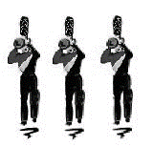

Hickman HS Florida Band Trip 2016

MANDATORY (Parent/Student) MEETING: Nov. 1, 6:30pm
Location TBD. Students w/ conflict must reschedule with directors.

REHEARSAL SCHEDULE:
October 26 (Wed.) 7:30am November 9 (Wed.) 7:30am
October 28 (Fri.) 7:30am November 14 (Mon.) 7:30am
November 2 (Wed.) 7:30am November 16 (Wed.) 7:30am
November 4 (Fri.) 7:30am November 18 (Fri.) 7:30am
November 20 (Sunday) Holiday Parade 3:00pm
November 21-17 BAND TRIP!!

